**COMSATS University Islamabad (CUI)**

**Project Proposal**

**for**

**Mihawk : Drone Surveillance System**

Version 1.02

***By***

**Hammad Ur Rehman CIIT/ FA21-BCS-055/ISB**

**Muhammad Hozefa Rauf CIIT/ FA21-BCS-057/ISB**

**Muhammad Usman Malik CIIT/FA21-BCS-072/ISB**

***Supervisor*Mr. Qasim Malik**

***Bachelor of Science in Computer Science (2021-2025)***

Contents

Abstract ii

1. Introduction 1

2. Problem Statement 1

3. Problem Solution/Objectives of the Proposed System 1

3.1 Objectives 2

4. Related System Analysis/Literature Review 2

5. Vision Statement 3

6. Scope 3

7. Modules 3

7.1 Module 1: Drone Control 3

7.2 Module 2: Surveillance and Threat Detection 4

7.3 Module 3: Alert Management 4

7.4 Module 4: Blockchain Integration 4

7.5 Module 5: User Management 4

7.6 Module 6: Surveillance Monitoring Interface 4

7.7 Module 7: Interactive Mapping and Location Visualization 5

7.8 Module 8: Data Handling 5

7.9 Module 9: Reporting and Analysis 5

7.10 Module 10: Admin Dashboard 5

7.11 Module 11: Raspberry Pi Integration 6

8. System Limitations/Constraints 6

9. Data Gathering Approach 7

10. Tools and Technologies 7

11. Project Stakeholders and Roles 8

12. Module based Work Division 8

13. WBS and Gantt Chart 9

14. Mockups 11

15. References 15

16. Plagiarism Report 17

**Project Category:**

■ **A-**Web Application/Web Application based Information System

■ **B-**Problem Solving and Artificial Intelligence

■ **C-**Image Processing■ **D-**Video Processing

# Abstract

The proposed drone surveillance system aims to address the need for advanced security and monitoring solutions in today's dynamic environments. Existing systems often lack real-time surveillance and threat detection capabilities, leading to security vulnerabilities and operational inefficiencies. This project seeks to overcome these challenges by offering a comprehensive solution for surveillance, threat detection, and data integrity assurance. Objectives include developing a manual flight control system, implementing advanced threat detection algorithms, and integrating block-chain technology for secure data storage. Additionally, the system will utilize an open-source drone assembled using modular components, and it will integrate Raspberry Pi for real-time video streaming via RTSP protocol, further enhancing flexibility and scalability. Through these efforts, the project aims to bridge gaps in current surveillance systems by providing a scalable, reliable, and transparent solution. The significance lies in its potential to revolutionize surveillance practices, offering improved threat detection, enhanced data security, and streamlined operational workflows.

# Introduction

**Mihawk** is an innovative drone surveillance system designed to transform security monitoring. By leveraging cutting-edge drone technology, open-source drone assembly with Raspberry Pi integration, and block-chain technology, Mihawk offers a robust solution for real-time surveillance, threat detection, and data integrity assurance. Key features include manual flight control for precise navigation, live surveillance feeds via Raspberry Pi using the RTSP protocol for immediate detection of threats such as weapons, fights, suspicious drones, and unattended baggage, and the use of block-chain technology for secure data storage and retrieval. The system not only improves response times from authorities but also reduces false alarms, ensuring quicker and more accurate threat identification. Mihawk enhances efficiency, transparency, and scalability in security operations, while smart contract integration automates tasks and ensures reliable data management, empowering security personnel with a cost-effective and highly reliable solution for enhanced situational awareness and threat mitigation.

# Problem Statement

Traditional surveillance systems are plagued by several critical limitations, including delayed response times, frequent false alarms, and fragmented data management. These systems often struggle to provide accurate, real-time threat detection, resulting in operational inefficiencies, especially in high-risk environments. Moreover, the data captured by these systems is often susceptible to tampering or loss, undermining the integrity of crucial information and diminishing the trustworthiness of security operations. As a result, security personnel are hindered in their ability to respond swiftly and effectively to emerging threats. With the growing complexity of modern security challenges, there is an urgent demand for a more advanced, scalable, and resilient surveillance solution that ensures real-time threat detection, data integrity, and rapid, informed decision-making.

# Problem Solution/Objectives of the Proposed System

The proposed system addresses these challenges by utilizing an advanced drone surveillance platform, featuring manual control, real-time threat detection, and secure data management. By deploying drones equipped with high-resolution cameras and powered by AI-driven software, the system provides continuous monitoring of critical areas, enabling the proactive detection of potential security threats. The integration of Raspberry Pi with RTSP video streaming ensures reliable live feeds, while block-chain technology safeguards data integrity by securely storing flagged surveillance footage and event logs. Our system is designed to adapt seamlessly to evolving security demands, dynamically responding to changing environments and emerging risks. It will offer real-time alerts and immediate response capabilities, ensuring swift action against suspicious activities. Additionally, machine learning algorithms will improve threat detection accuracy by analyzing patterns and behaviors, reducing false alarms and enhancing overall system reliability. This holistic, scalable solution enhances situational awareness, accelerates response times, and strengthens security measures, resulting in more efficient, reliable, and effective threat mitigation.

.

## Objectives

BO-1: Enhance surveillance coverage by implementing drones with manual control to eliminate blind spots and provide 180-degree monitoring.  
BO-2: Detect and alert authorities about security threats promptly.  
BO-3: Ensure high accuracy in detecting security-related events.  
BO-4: Reduce response time to security incidents.  
BO-5: Integrate predictive analytics to identify suspicious behavior patterns, alerting authorities, and enhancing proactive threat detection to minimize security breaches.

# Related System Analysis/Literature Review

Table 1 shows three related systems Skydio Autonomy, SenseFly eBee X , Quantum Systems Trinity F90+

Table 1 Related System Analysis with proposed project solution

|  |  |  |
| --- | --- | --- |
| **Application Name** | **Weakness** | **Proposed Project Solution** |
| Skydio Autonomy [1] | Primarily focuses on autonomous flight; less flexible for dynamic environments. | Mihawk integrates manual control with real-time threat detection and secure data management for greater adaptability. |
| SenseFly eBee X [2] | Lacks real-time threat detection; used mainly for pre-planned flights. | Mihawk offers real-time monitoring and AI-driven threat detection, making it more responsive to dynamic situations. |
| Quantum Systems Trinity F90+ [3] | Focuses on endurance and high-resolution imaging; lacks advanced real-time analysis. | Mihawk combines manual control with advanced AI and blockchain for comprehensive, real-time surveillance capabilities. |

# Vision Statement

For security agencies and organizations tasked with surveillance operations in various environments, Mihawk: the Drone Surveillance System is an advanced aerial platform designed to manually patrol and monitor designated areas, detect potential threats, and provide real-time situational awareness. Unlike traditional manned surveillance methods or stationary CCTV systems, our product leverages cutting-edge manual flight control and computer vision technologies to offer persistent, scalable, and cost-effective surveillance solutions. Our system empowers users to safeguard critical assets, infrastructure, and personnel while adapting efficiently and effectively to dynamic and evolving security challenges.

# Scope

This project involves the development of a drone surveillance system with a focus on manual flight control, real-time surveillance, threat detection, data visualization, and secure data storage. Key functionalities include implementing manual flight control for navigating designated routes and enabling users to access live surveillance feeds and recorded footage through a user-friendly web interface using real-time video streaming technologies. The system will utilize the RTSP protocol via Raspberry Pi to stream real-time video feeds, ensuring reliable and high-quality surveillance data transmission. Advanced algorithms will analyze surveillance footage to detect security threats or anomalies, while interactive visualization tools will allow users to interpret data on maps and dashboards for enhanced situational awareness. Additionally, the system will integrate blockchain technology to securely store threat detection timestamps, minimizing the risk of data tampering and optimizing blockchain resource usage. User management features, including authentication, authorization, and role-based access control, will further enhance security, alongside administrative tools for system configuration, incident management, and reporting. This project aims to deliver a scalable, user-friendly solution for improving security and situational awareness across various applications.

# Modules

## Module 1: Drone Control

FE-1: Manual flight control system for drones to navigate on the routes.  
FE-2: Integrate weather data APIs to adjust flight plans based on weather conditions.  
FE-3: Real-time monitoring of drone status and location.  
FE-4: Provide controls for emergency procedures in case of unexpected situations during flight.

## Module 2: Surveillance and Threat Detection

FE-1: Implement real-time video processing algorithms to analyze surveillance footage for potential threats or anomalies.

FE-2: Develop object detection algorithms to identify and classify objects of interest in the surveillance feed.

FE-3: Design threat identification algorithms to detect and categorize security threats based on detected objects or behaviors.

FE-4: Develop algorithms for crowd behavior analysis to detect suspicious activities in crowded areas.

FE-5: Customizable threat detection settings for specific security requirements and environments.

## Module 3: Alert Management

FE-1: Real-time alerts and notifications for security incidents or unusual activities.

FE-2: Priority-based alert categorization and escalation procedures for timely response.

FE-3: Integration with existing security systems for seamless alert management and coordination.

## Module 4: Blockchain Integration

FE-1: Set up and configure a blockchain network for secure and tamper-proof storage of surveillance data.

FE-2: Implement data encryption mechanisms to ensure the security and integrity of stored surveillance data.

## Module 5: User Management

FE-1: User authentication and authorization mechanisms for secure access to the system.

FE-2: Role-based access control to restrict functionalities based on user roles and permissions.

FE-3: Enable user to edit profile information (password).

FE-4: Implement a secure password reset functionality where user can retrieve forgotten passwords through email verification or security questions.

FE-5: Audit trail functionality to track user activities and changes made to the system.

FE-6: Implement 2-Factor Authentication for better security.

## Module 6: Surveillance Monitoring Interface

FE-1: Design a user-friendly web interface for operators to monitor and control the surveillance system.

FE-2: Develop features to display live surveillance feed and playback recorded footage on the web application.

FE-3: Provide interactive controls for drone control

FE-4: Implement real-time status indicators for the network, battery levels, and connection status.

## Module 7: Interactive Mapping and Location Visualization

FE-1: Interactive maps and visualization tools for displaying drone locations and surveillance data.

FE-2: Provide search functionality for users to selectively view specific types of surveillance data or events.

FE-3: Implement zoom and pan functionality for detailed exploration of surveillance data and maps.

FE-4: Integrate real-time weather data overlays to visualize weather conditions and their impact on surveillance operations.

FE-5: Implement dynamic data filtering options to enable users to filter surveillance data by criteria like time, location, or activity type for focused analysis and monitoring.

## Module 8: Data Handling

FE-1: Develop mechanisms to efficiently store captured images or videos on the blockchain.

FE-2: Implement functionality to retrieve stored surveillance data from the blockchain for analysis or playback.

FE-3: Implement data compression techniques to reduce storage requirements without compromising quality.

FE-4: Integrate data lifecycle management policies to automatically archive or delete outdated surveillance data.

## Module 9: Reporting and Analysis

FE-1: Reporting functionalities to generate detailed reports on surveillance activities and incidents.

FE-2: Advanced analytics tools for deep dive analysis of surveillance data and trends.

FE-3: Export functionalities to save reports and analytics data in various formats for sharing and archival purposes.

## Module 10: Admin Dashboard

FE-1: Design a user-friendly interface for administrators to monitor and manage the surveillance system efficiently.

FE-2: Enable administrators to manage user accounts, including creating, editing, and deleting user profiles, as well as assigning roles and permissions.

FE-3: Provide a comprehensive overview of system status, including drone fleet health, surveillance coverage, and alert summaries.

FE-4: Allow administrators to configure system settings, such as geofence parameters, alert thresholds, and data retention policies.

FE-5: Design reporting tools to generate insights on system performance, alert trends, and operational metrics for analysis.

## Module 11: Raspberry Pi Integration

FE-1:Configure Raspberry Pi to stream real-time video from the drone’s camera using the Real-Time Streaming Protocol (RTSP). This allows for live monitoring of surveillance feeds over the network.

FE-2: Enable integration of various camera modules and sensors with the Raspberry Pi, providing flexibility for different surveillance and data collection needs.

FE-3:Implement data compression techniques on the Raspberry Pi to ensure efficient transmission of high-quality video streams with minimal bandwidth usage.

FE-4:Integrate power management features to monitor and optimize the Raspberry Pi’s energy consumption, ensuring it operates efficiently during drone flights.

FE-5: Use Raspberry Pi for real-time processing of surveillance data (e.g., object detection) to reduce latency before data is sent to the central system, improving threat detection capabilities.

# System Limitations/Constraints

LI-1: Drone surveillance operations are constrained by the limited battery life of drones, but the surveillance system lessens this impact through optimized flight routes and rapid battery charging capabilities, ensuring continuous surveillance missions.

LI-2: Weather Conditions: Adverse weather conditions such as strong winds and rain can affect the performance and reliability of drone surveillance systems, leading to reduced visibility and operational limitations, but the surveillance system will hold a possibility of switching to safe city cameras to provide surveillance to some extent.

LI-3: Regulatory Compliance: Drone operations are subject to various regulations and restrictions imposed by aviation authorities, which may limit the areas where drones can fly and the altitudes they can reach.

LI-4: Payload Capacity: Drones have limited payload capacity, which may constrain the types of sensors, cameras, and equipment that can be carried for surveillance purposes.

# Data Gathering Approach

To understand user needs and system requirements thoroughly for the proposed project, we will use a blend of information gathering methods. This will involve engaging in consultations with subject matter experts. Additionally, we will analyze existing literature, research papers, and industry standards related to drone surveillance systems to get insights into best practices, emerging technologies, and regulatory requirements that could influence system design and development.

# Tools and Technologies

Table 2 shows the tools and technologies used for our project.

Table 2: Tools and Technologies for Proposed Project

|  |  |  |  |
| --- | --- | --- | --- |
| **Tools**  **And**  **Technologies** | **Tools** | **Version** | **Rationale** |
| MS Visual Studio | 2022 | IDE |
| MS SQL Server | 2015 | DBMS |
| Figma | 16 | Design Work |
| DroneKit | 2.9.1 | Active community support, compatibility with various drone platforms |
| MongoDB | 2022 | DBMS |
| OAuth | 2.0 | Authentication in web applications |
| Git/Github | - | Version control system and hosting platform for managing source code repositories. |
| Docker | 20.10 | Containerization tool for consistent deployment of applications. |
| **Technology** | **Version** | **Rationale** |
| React JS | 18.2 | Front-end Development |
| Node JS | 14 | Back-end Development |
| Angular | 17.0.0 | Front-end Development. |
| Solidity | 0.8 | Blockchain Development |
| Python | 3.11.10 | Machine Learning Models |
| Tensorflow | 2.8 | Framework for building and deploying machine learning models. |
| Pytorch | 1.10 | Framework for deep learning with dynamic computational graphs. |
| Pandas | 1.3.3 | Library for data analysis and analysis |
| Flask | 2.0 | Lightweight web framework for creating APIs for serving machine learning models. |

# 

# Project Stakeholders and Roles

Table 3 shows the stakeholders and their roles in our project.

Table 3 Project Stakeholders for Proposed Project

|  |  |
| --- | --- |
| **Project Sponsor** | COMSATS University Islamabad, Islamabad Campus |
| **Stakeholder** | * Muhammad Usman Malik (FA21-BCS-072) * Muhammad Hozefa Rauf (FA21-BCS-057) * Hammad Ur Rehman (FA21-BCS-055) * Project Supervisor Name: Mr. Qasim Malik * Final Year Project Committee: Evaluation of project |

# Module based Work Division

Table 4 shows the module work division for our project.

Table 4 Team Member Work Division for Proposed Project

|  |  |  |
| --- | --- | --- |
| **Student Name** | **Student Registration Number** | **Responsibility/ Module / Feature** |
| Hammad Ur Rehman | FA21-BCS-055 | Module1- Feature 1,  Module2- Feature 2-3,  Module4- Feature 1-2,  Module8- Feature 1-2,  Module10- Feature 2,  Module11- Feature 4 |
| Muhammad Hozefa Rauf | FA21-BCS-057 | Module1- Feature 1,3,  Module2- Feature 1,  Module3- Feature 1-3,  Module5- Feature 1-5,  Module6- Feature 1-4,  Module10- Feature 3,  Module11- Feature 5, |
| Muhammad Usman Malik | FA21-BCS-072 | Module1- Feature 4,  Module2- Feature 4-5,  Module7- Feature 1-5,  Module8- Feature 3-4,  Module9- Feature 1-3,  Module10- Feature 1,  Module11- Feature 1-3 |

# WBS and Gantt Chart

Figure 1 displays the Gantt chart for the Mihawk: Drone Surveillance System.

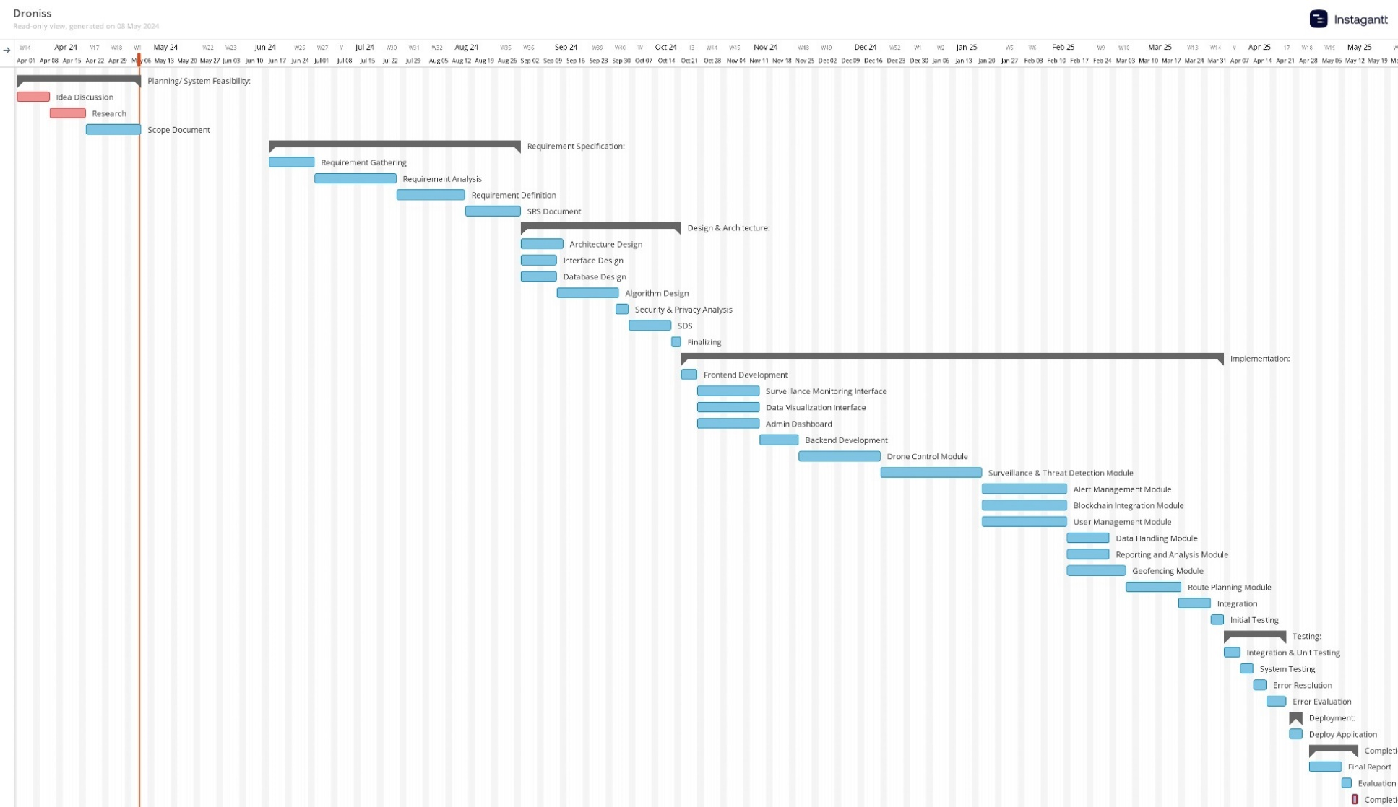

Figure 1: Gantt Chart

Figure 2 shows the work breakdown structure for Mihawk: Drone Surveillance System.

Figure 2:WBS For Mihawk: Drone Surveillance System

# Mockups

Fiqure 3 shows the landing page mockup features a centralized "Sign In" button, with a navigation bar offering easy access to the Home, About, and Contact sections.

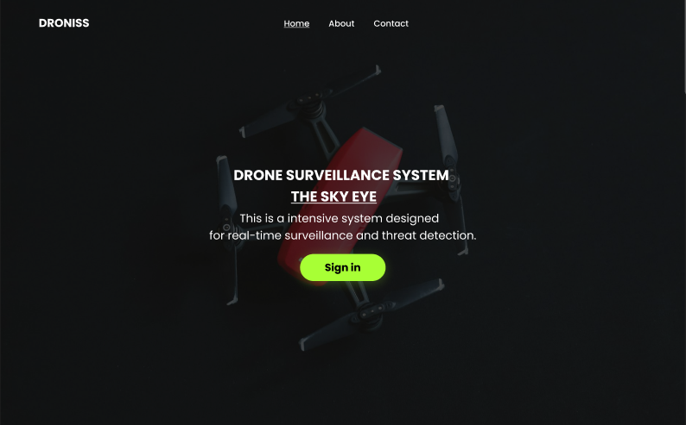

Figure 3: Landing Page

Fiqure 4 shows the locating drone page mockup within the dashboard showcases real-time drone locations on an interactive map interface.

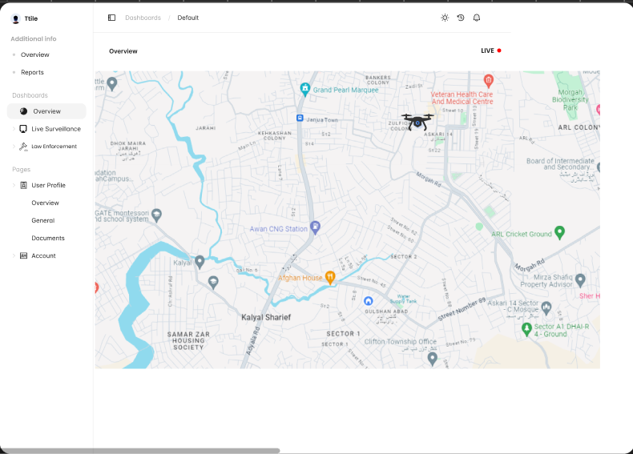

Figure 4: Locating Drone

*Fiqure 5* *shows t*he live surveillance screen mockup presents a dynamic interface where users can view live camera footage, access other recorded footage, and initiate playback seamlessly.

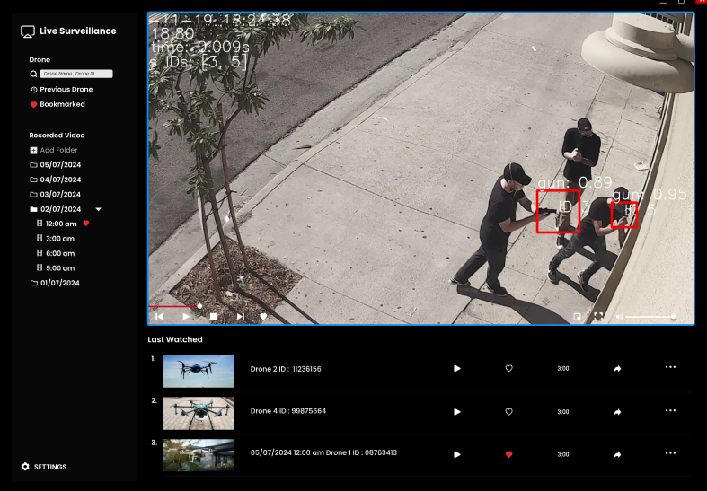

Figure 5: Live Surveillance Screen

Fiqure 6 shows the Law Enforcement Coordination mockup provides a comprehensive display of information and status updates of law enforcement agencies, ensuring efficient coordination and communication in real-time.

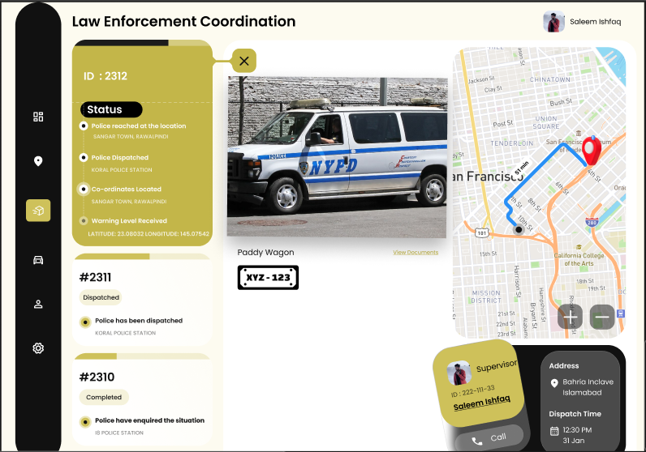

Figure 6: Law Enforcement Co-ordination

Fiqure 7 shows the Analytics page mockup within the admin dashboard offers detailed analysis of surveillance data and provides administrators with access to all existing surveillance footage for monitoring and review.

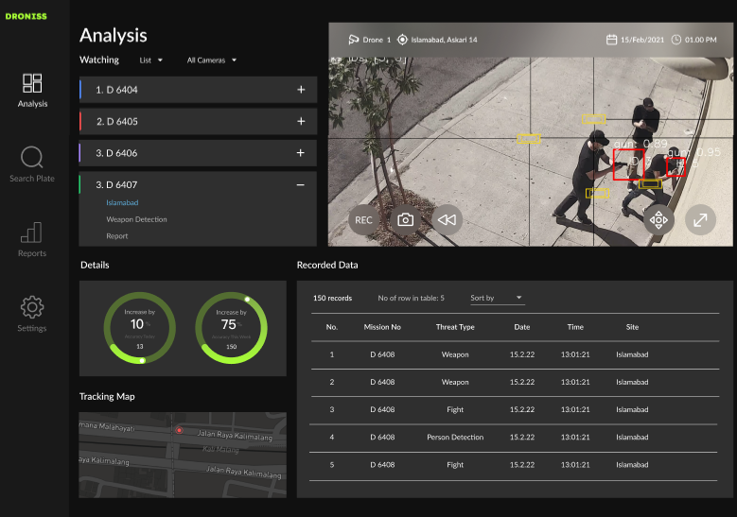

Figure 7: Analytics

Fiqure 8 shows the User Profile mockup allows users to view and edit their personal information, while also providing access to past surveillance data for review and analysis.

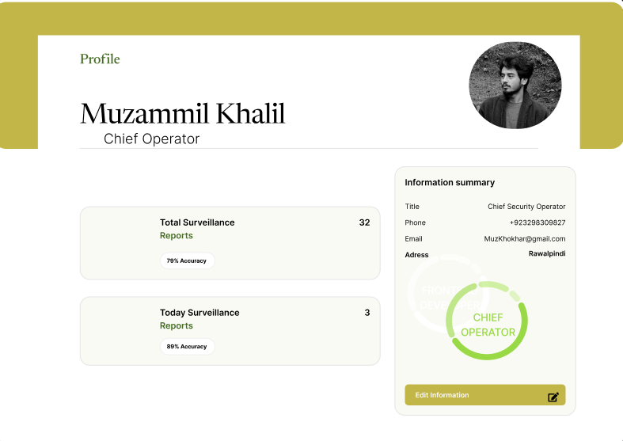

Figure 8 : User Profile

# References

1. Jensen, C. S., Lauritsen, M. L., & Majgaard, G. (2018). Geometric Tools for Computer Graphics. San Francisco, CA: Morgan Kaufmann.
2. Russell, S., & Norvig, P. (2016). Artificial Intelligence: A Modern Approach. Upper Saddle River, NJ: Pearson.
3. Wu, B., Ai, Y., Liao, W., & Zeng, J. (2019). A Real-Time Object Detection Algorithm Based on YOLOv3 for Unmanned Aerial Vehicle. IEEE Access, 7, 89669-89677.
4. Lin, T. Y., Dollár, P., Girshick, R., He, K., Hariharan, B., & Belongie, S. (2017). Feature Pyramid Networks for Object Detection. In Proceedings of the IEEE Conference on Computer Vision and Pattern Recognition (CVPR), pp. 2117-2125.
5. Federal Aviation Administration. (n.d.). Unmanned Aircraft Systems. https://www.faa.gov/uas/
6. Open Geospatial Consortium. (n.d.). Geospatial Standards. https://www.ogc.org/
7. Ghosh, S., Manandhar, A., & Fookes, C. (2020). Deep Learning-Based Anomaly Detection for Surveillance Videos: A Survey. arXiv preprint arXiv:2005.02369.
8. Liu, J., Luo, Z., & Wu, Z. (2019). A Survey of Deep Learning-Based Object Detection. IEEE Access, 7, 128837-128868.
9. Violence Object Detection Dataset (v1, 2022-10-19 12:28pm) by shah. (n.d.). Roboflow. https://universe.roboflow.com/shah-xxxqs/violence-3h8pw/dataset/1
10. Ajv. (n.d.). GitHub - AJV009/risk-package-detection: [Fun app] A simple Object Detection and Tracking based project to alarm harmful objects and unattended packages (YOLO + OpenVINO + DeepSORT). GitHub. https://github.com/AJV009/risk-package-detection
11. Weapon Detection Dataset. (2023, February 15). Kaggle. https://www.kaggle.com/datasets/snehilsanyal/weapon-detection-test/data
12. *Weapon Detection using YOLOv8 Object Detection Dataset (v1, 2023-11-16 6:16am) by Weopon Detection*. (n.d.). Roboflow. https://universe.roboflow.com/weopon-detection/weapon-detection-using-yolov8/dataset/1

# Plagiarism Report

